OpenCV is one of the most popular computer vision libraries. If you want to start your journey in the field of computer vision, then a thorough understanding of the concepts of OpenCV is of paramount importance.  
In this article, I will try to introduce the most basic and important concepts of OpenCV in an intuitive manner.  
**This article will cover the following topics:**

1. Reading an image
2. Extracting the RGB values of a pixel
3. Extracting the Region of Interest (ROI)
4. Resizing the Image
5. Rotating the Image
6. Drawing a Rectangle
7. Displaying text

This is the original image that we will manipulate throughout the course of this article.

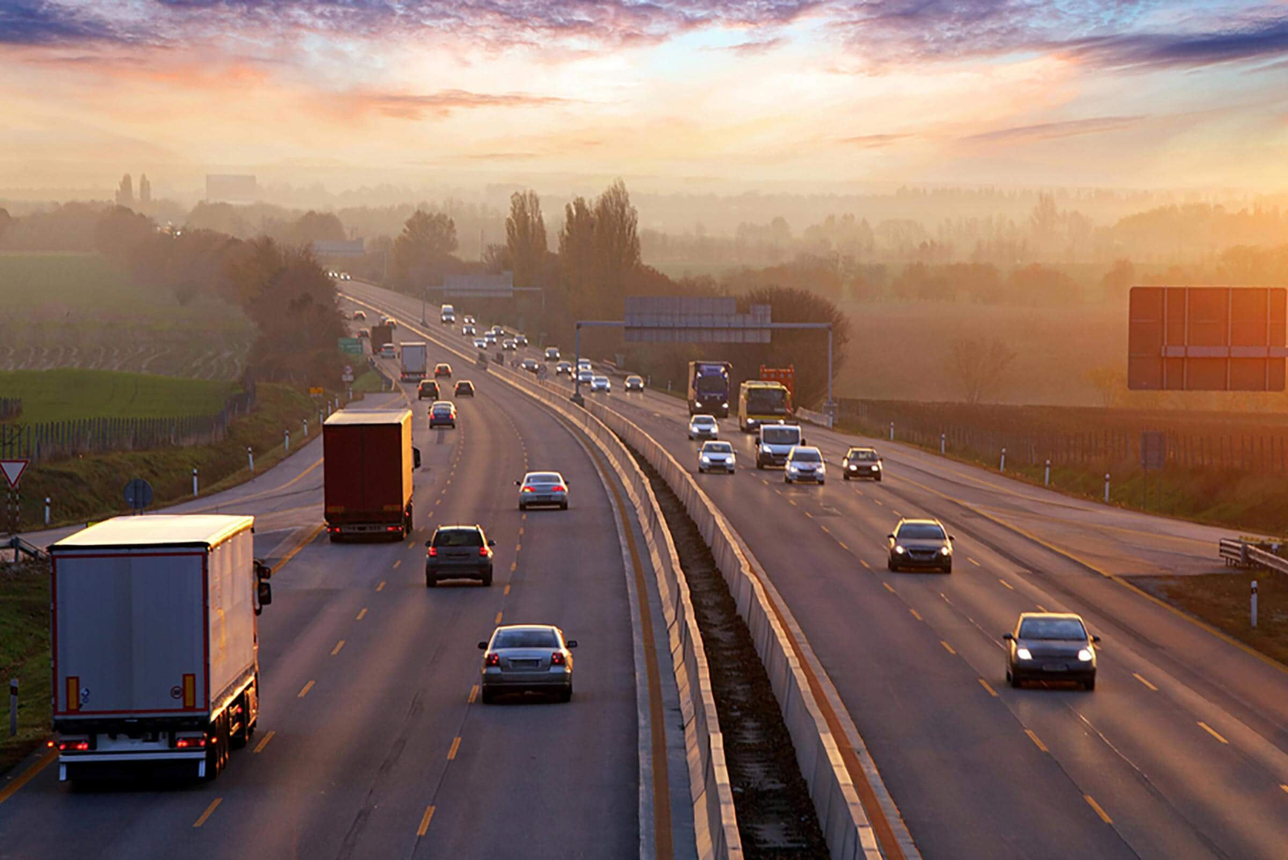

Let’s start with the simple task of reading an image using OpenCV.

**Reading an image**

|  |
| --- |
| # Importing the OpenCV library  import cv2  # Reading the image using imread() function  image = cv2.imread('image.png')    # Extracting the height and width of an image  h, w = image.shape[:2]  # Displaying the height and width  print("Height = {},  Width = {}".format(h, w)) |

Now we will focus on extracting the RGB values of an individual pixel.  
Note – OpenCV arranges the channels in BGR order. So the 0th value will correspond to Blue pixel and not Red.

**Extracting the RGB values of a pixel**

|  |
| --- |
| # Extracting RGB values.  # Here we have randomly chosen a pixel  # by passing in 100, 100 for height and width.  (B, G, R) = image[100, 100]    # Displaying the pixel values  print("R = {}, G = {}, B = {}".format(R, G, B))    # We can also pass the channel to extract  # the value for a specific channel  B = image[100, 100, 0]  print("B = {}".format(B)) |

**Extracting the Region of Interest (ROI)**

|  |
| --- |
| # We will calculate the region of interest  # by slicing the pixels of the image  roi = image[100 : 500, 200 : 700] |

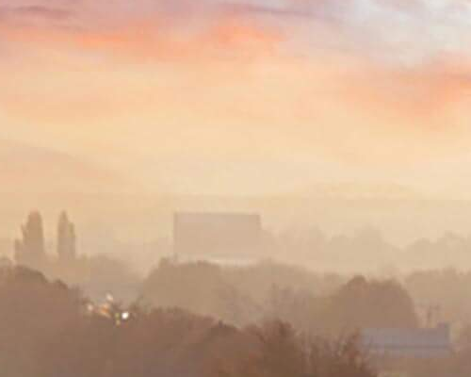

**Resizing the Image**

|  |
| --- |
| # resize() function takes 2 parameters,  # the image and the dimensions  resize = cv2.resize(image, (800, 800)) |

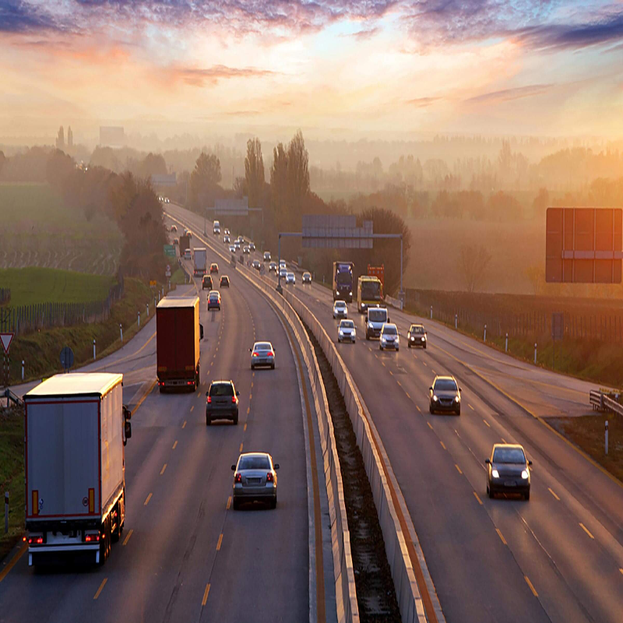

The problem with this approach is that the aspect ratio of the image is not maintained. So we need to do some extra work in order to maintain a proper aspect ratio.

|  |
| --- |
| # Calculating the ratio  ratio = 800 / w    # Creating a tuple containing width and height  dim = (800, int(h * ratio))    # Resizing the image  resize_aspect = cv2.resize(image, dim) |

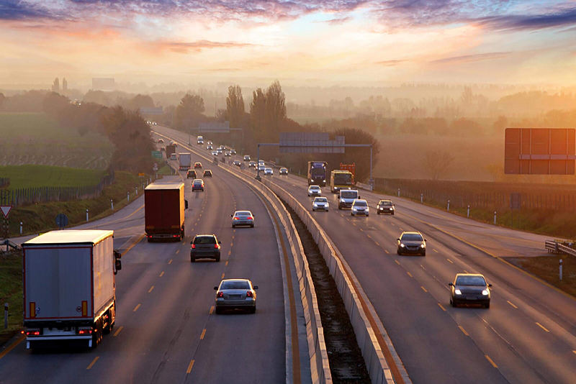

**Rotating the Image**

|  |
| --- |
| # Calculating the center of the image  center = (w // 2, h // 2)    # Generating a rotation matrix  matrix = cv2.getRotationMatrix2D(center, -45, 1.0)    # Performing the affine transformation  rotated = cv2.warpAffine(image, matrix, (w, h)) |

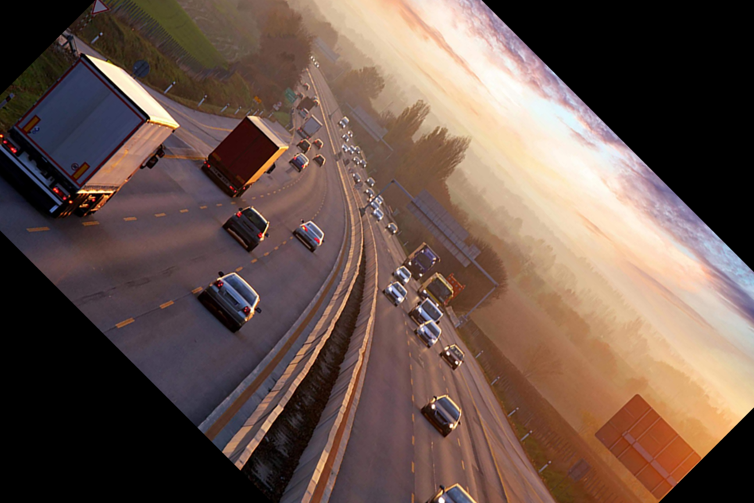

There are a lot of steps involved in rotating an image. So, let me explain each of them in detail.

The 2 main functions used here are –

* getRotationMatrix2D()
* warpAffine()

**getRotationMatrix2D()**  
It takes 3 arguments –

* **center –** The center coordinates of the image
* **Angle –** The angle (in degrees) by which the image should be rotated
* **Scale –** The scaling factor

It returns a 2*3 matrix consisting of values derived from alpha and beta  
alpha = scale * cos(angle)  
beta = scale * sine(angle)

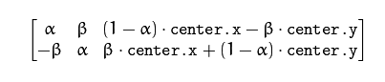

**warpAffine()**

The function warpAffine transforms the source image using the rotation matrix:

dst(x, y) = src(M11X + M12Y + M13, M21X + M22Y + M23)

Here M is the rotation matrix, described above.  
It calculates new x, y co-ordinates of the image and transforms it.

**Drawing a Rectangle**  
It is an in-place operation.

|  |
| --- |
| # We are copying the original image,  # as it is an in-place operation.  output = image.copy()    # Using the rectangle() function to create a rectangle.  rectangle = cv2.rectangle(output, (1500, 900),                            (600, 400), (255, 0, 0), 2) |

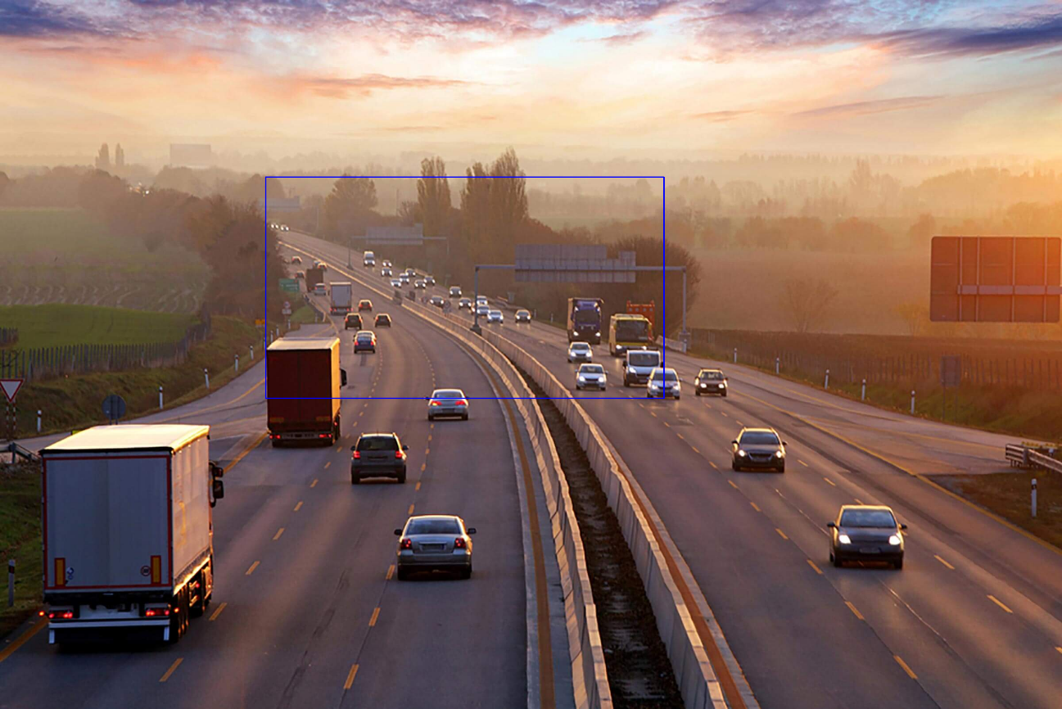

It takes in 5 arguments –

* + Image
  + Top-left corner co-ordinates
  + Bottom-right corner co-ordinates
  + Color (in BGR format)
  + Line width

**Displaying text**  
It is also an in-place operation

|  |
| --- |
| # Copying the original image  output = image.copy()    # Adding the text using putText() function  text = cv2.putText(output, 'OpenCV Demo', (500, 550),                     cv2.FONT_HERSHEY_SIMPLEX, 4, (255, 0, 0), 2) |

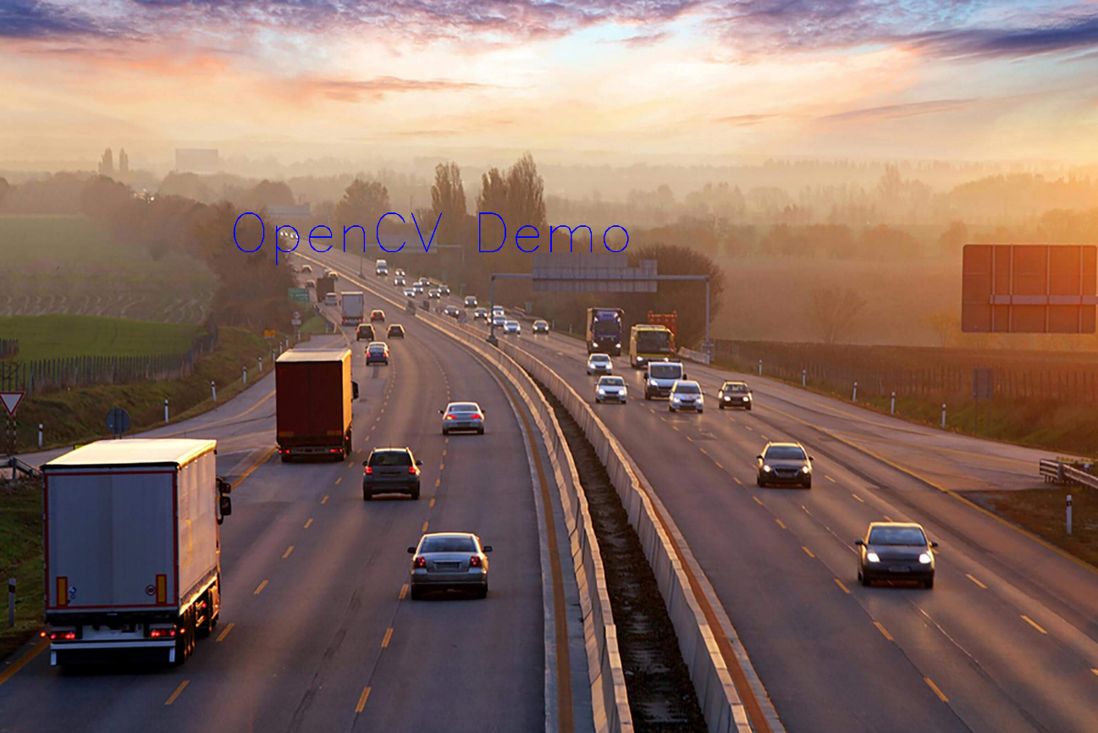

It takes in 7 arguments –

* + Image
  + Text to be displayed
  + Bottom-left corner co-ordinates, from where the text should start
  + Font
  + Font size
  + Color (BGR format)
  + Line width

www.camerinfloks.com